UNIX SOCKET:
SERVER INPUT:
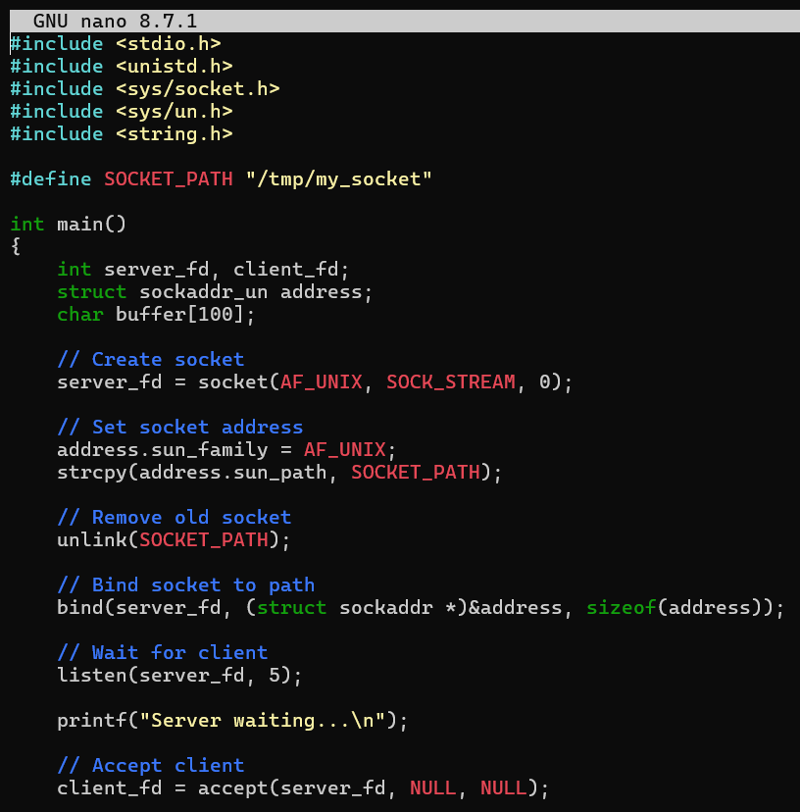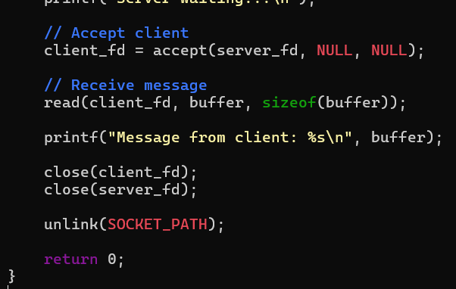
CLIENT INPUT:
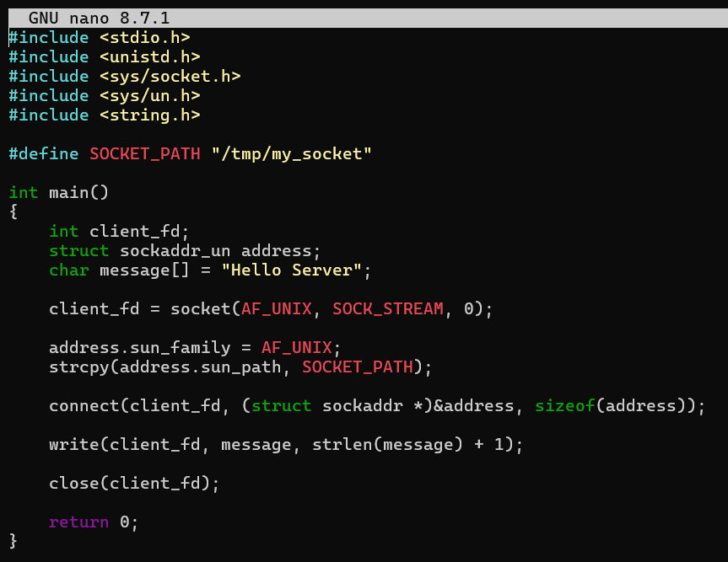
CLIENT OUTPUT:
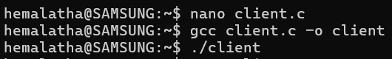
SERVER OUTPUT:
